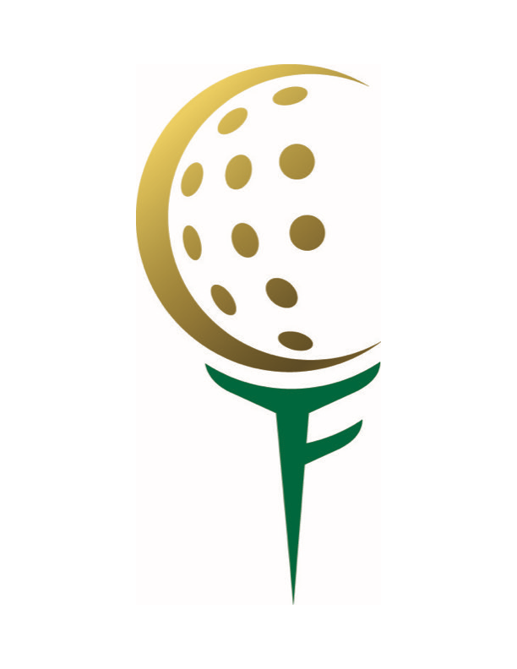

It has been a privilege and an honor to be a member of the Fairway Club since 1999 and I am deeply indebted to my sponsor, Jeff Hugo. At the time I didn't realize what a great group of guys I'd be forming friendships with and what great courses I’d play each year. Who knew it would lead to overseas trips to Ireland, Scotland and to great stateside trips as well in the ensuing years. Certainly the highlight of 2014 for me was our Fairway Club trip to Latrobe, Pa. to play Latrobe Country Club and meet with the King himself, Arnold Palmer. Thank you Howdy Giles who was Arnold's dentist, lifetime friend and Fairway Club member.

I do have one humorous story about my first dinner with the Fairway Club at Aronimink. I was being proposed as a member and sat next to President, Ed McKeon and former President, Dick Goldbeck. My attire was business casual. I played well that day and even though I wasn't a member yet I received a golf ball for having low gross. After dinner was over, Ed (a former Marine Corps fighter pilot) leaned over to me and said…… Lloyd we like you and we like your golf game but next time wear a “blankety-blank” tie. My response was Yes Sir!

Over the 20 years I've been a member I have enjoyed what great camaraderie the Fairway Club members have with each other. We may see each other only six – eight times a year but it always seems like it was just yesterday when we get together. A lot of this feeling flows down from the Board which always sets a great example of fellowship. As current members of the Fairway Club we are all extremely lucky to be part of such an illustrious organization. Happy 100th Fairway Club. Play away, Gentlemen.

Lloyd McGinley- member since 1999